

**Cities in transition: locality, identity and experience of place** *issues for migrant and minority ethnic groups in rapidly emerging urban developments and typologies*

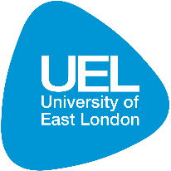

UK Coordinator: Alan Chandler, Reader in Architecture, Leader of Research - Architecture and the Built Environment, University of East London with Dr. Heba Elsharkawy, Dr. Anastasia Karandinou, Dr. Bridget Snaith.

Partner Country Coordinator: Dr. Ela Alanyalı Aral, Associate Professor, Department of Architecture, Middle East Technical University with Özlem Erdoğdu Erkarslan -Prof.Dr., Independent Researcher, Neslihan Demirtaş-Milz -Assoc.Prof.Dr., İzmir Katip Çelebi University

**Dates and Venue: 23rd to the 27th October 2017, Ankara, METU**

**Deadline for Application:1st July 2017**

*The language of the workshop is in English.*

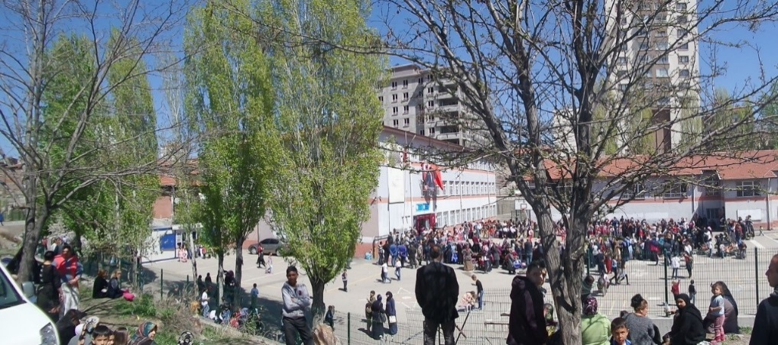 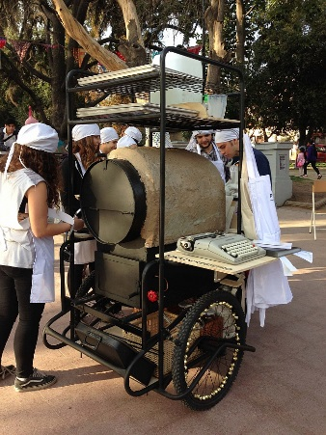

Ankara - Ela Alanyalı Aral - Santiago Catalina Pollak

THEME:

Urban transformation and mobility is increasingly rapid. The potential loss of identity and ‘sense of place’ in an urban environment is disempowering, with significant consequences to social cohesion. This workshop will focus on issues of public spaces, sense of identity, ‘placelessness’ and wellbeing in the context of global mobility.

We situate the conditions of ‘new migrants’ into wider concerns over a lack of ‘belonging’ in the 21st century urban realm, and develop tools and agendas to discuss placelessness not only amongst incomers, but amongst those already resident in the city.

Turkey has recently announced the official numbers of Syrian refugees in Turkey as 3 million 551 thousand and 78. This newly added population is roughly equal to the total population of 17 different cities in Turkey. The state has spent roughly 25 billion US dollars for the immediate accommodation and basic services for the refugees since 2011, with only 725 million dollars covered by EU funds. Funds designated for the Syrian population remain insufficient since many of the newcomers do not have access to public services and basic comfort conditions.

The latest migration flow also accelerated the existing spatial and social attachment problems in the cities of Turkey. Similarly, rapidly changing demographics in Europe and concerns on its cohesion need to be closely analysed in order to propose architectural and urban strategies that will bridge perspectives of the new comers and residents of the cities. Urban spaces can be produced regarding the needs and habitual practices of the new comers’ with the approach of participatory design. In order to formulate adequate research projects around this target our workshop will focus on two key questions:

1. Can spatial configuration support social cohesion, foster positive interaction, support varied spatial and economic practices?
2. How can already fragile neighbourhoods be helped to feel invigorated by new populations, rather than feel threatened or overwhelmed?

DISCIPLINES AND SECTORS TO BE INVOLVED

The participants in the workshops will be encouraged to engage with different sectors such as economists, sociologists, architects, planners and other users by making visits and discussions to specific sites. It is also planned to set up a dialogue between the migrants, local inhabitants, practitioners (architects, designers, urban planners), and local authorities by arranging group discussions; in this way, academics could orchestrate knowledge in relation to legal and operational constraints to support new initiatives. In this respect, engagement with migrants and local communities from the onset of the research will ensure that the outcomes are of benefit to them. In the long term, these give feedback to decision makers to effect policy and enable change to the ground.

FORMAT OF THE WORKSHOP

The workshop will take place in Ankara between 23rd and 27th October 2017. The selected participants will be invited to present their previous research related with the topic in a poster session to share their expertise, approach, methodologies and past experiences in the field. Before the formal working sessions begin the participants will be invited to site trips in the city in order to diagnose the problems and contact with the local communities. Working groups for 7-8 participants will be brought together in parallel sessions, the results of which will be shared at the end of the day and during the informal social events.

BENEFITS

The British Council and Newton Fund will cover the costs related to the participation to the workshop, including: travel (both international and local), accommodation and meals. Costs for the visa will be covered; however participants will be responsible for making all the necessary arrangements. Participants are encouraged to purchase an adequate travel or medical insurance as this is not covered by the British Council. The British Council accepts no responsibility or liability for any problems that may occur when the participants are in-country.

ELIGIBILITY

Researchers based in UK or Turkey at an early stage in their research careers are invited to take part in the workshop, dealing with a core problem of place identity and community identification in urban research. Those who have previous research interests in the subjects listed below will be eligible:

Urban Migration

Participatory Design Practice / Theory

Urban Mapping

Urban Space and Identity

Urban Experience

Public Space

Politics of Urban Space

Sociology of Migration

Conflict Resolution

Urban Poverty

Visualisation of Lived Space (Art, Photography and Film)

#### The quota is limited to 34 participants, 17 from the UK and 17 from Turkey. No more than a third of early career researchers may be recruited from the host institutions of UEL or METU.

#### Applications must be submitted using the form link below to: [earal@metu.edu.tr](mailto:earal@metu.edu.tr)

* Application must be submitted before the above deadline.
* Participants must be Early Career Researchers: Early Career Researchers are defined as holding a PhD and having up to 10 years post-PhD research experience. If a researcher does not hold a PhD but has research experience equivalent to a PhD holder and works in a field where a PhD is not a pre-requisite for established research activity, such as architecture, they are still eligible.
* Participants must have a research or academic position (a permanent post, research contract, or fellowship etc.) at a recognised research institution either in the UK or in Turkey.
* Please note that participants are expected to attend all sessions of the workshop.

Quality Assessment

* Experience and relevance of the applicant’s research area to the workshop;
* Motivation and contribution to the aims of the workshop;
* Description of the long term impact expected through the participation in the workshop;
* Ability to disseminate workshop’s outcomes.

Selection Procedure

1. Eligibility check
2. Quality Assessment

Key dates

**Applications must be submitted by 1st July 2017.**

**Applicants will be notified by email by the end of 21st July 2017.**





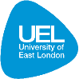

**Cities in transition: locality, identity and experience of place** *issues for migrant and minority ethnic groups in rapidly emerging urban developments and typologies*

Name and Title*

Gender*

Institution*

Postal Address *

Address line one:

Address line two:

Address line three:

City

Country

Post Code

Email address*

Phone Number

Please attach CV

Please describe your motivation for attending the workshop and how the workshop matches your professional development needs in not more than 200 words*

Please continue

Please describe the expected impact of your participation on your personal and professional development, including your ability to work internationally in not more than 200 words

Please indicate how you will disseminate the outcomes of the workshops and the new knowledge/skills you have acquired in not more than 200 words *

The workshop will take place in English as standard. Please indicate your ability to work and communicate in English. *

Native Speaker Excellent Good Need Support

Any additional information please include